Using Workflow Management Systems Intro

By Joseph DeArce 11/19/19

Introduction
Chapter 1

What is Workflow Management

A Workflow Management System or Tool is a software application that manages the movement and automation of data between systems through an API, command line or GUI (web or Desktop/Server client).

While the term 'Dataflow' is used in many ways, here it’s used to mean the automated and managed flow of information between systems. This type of application has been around ever since enterprises had more than one system, where some of the systems created data and other systems consumed data. The problems and solutions that emerged have long been discussed as well as the patterns these systems generated in many technical papers. A comprehensive discussion about Dataflow Systems can be found by searching for Enterprise Integration Patterns.

These types of systems provide several key functions or features, they are:
- Strong security.
- Support interactivity.
- Are highly scalable (horizontally scalable).
- Support Clustering.
- Support data lineage (the application keeps multiple copies of the data to show what changes were done to the data over time).
- Provenance (i.e. a data life-cycle measure detailing data’s origin and why, how and where it moves over a period).
- Workflow is designed as a directed acyclic graph (DAG).

Some Challenges to overcome
Most of the Workflow Management Systems are now under the auspices of the Apache Software Foundation. The ASF is an all-volunteer organization that stewards, develops, incubates projects and currently oversees more than 350 open source projects and initiatives.

Some of the high-level challenges of workflow systems include:
- System fails.
- Network failures.
- Drive failures.
- Software crashes.
- Data velocity exceeds capacity to process the data.
- A given data source can outpace some part of the processing or delivery chain, it only takes one weak link to cause this problem.
- Data corruption and data gaps.

Occasionally there will be situations with data that is too big, too small, too fast, too slow, corrupt, wrong, or in the wrong format. These systems must be able to scale horizontally have low latency and be flexible in processing the flows.

What is Workflow Management for?
Workflow Management is the creating and optimizing of paths for data processing in order to complete the items in a given process stream. It includes mapping out the workflow in an ideal state, finding redundant tasks, automating the process, and identifying bottlenecks or areas for improvement.

A Workflow Management System is a software tool designed to help streamline routine of business processes for optimal efficiency. Workflow Management Systems involve the creating a form to hold data and setting a sequential path of tasks for the data to follow until it is fully processed. It will automatically route the data to the predetermined tasks.

Smart company leaders are looking at business process management software, to automate their workflows, to achieve a new level of efficiency. But in 2019, the search for a Workflow Management System is a mixture of Open source and some commercial options and so is hard to find the right tool for your environment.

The tasks in workflows can be done by either humans using computers or a system using management software. With so many options and so many products *calling themselves a workflow tool, it’s hard to know what you will get.

Whatever the state of your workflow management, using the right WMS tool with the right features is critical for success.

What Does a Workflow Management System (WMS) Do?
Workflow Management Systems automate and automatically follows up on uncompleted tasks in a process flow or informs the operator/owner of the failure. These systems give an overall picture of the workflow along with performance metrics and have a robust reporting system.

To get the true value for the money that a WMS promises, it should at least have these 10 basic features.

What features does a Workflow Management have?
The 10 Features that every Workflow Management System Should Have are:

1. Intuitive, Code-Free Workflow Designer. A great Workflow Management System lets you think in simple linear loops and does all the complex stuff in the background.

2. Integration with Other Services and systems
Integration used to be nice to have feature for workflow management systems. Now it’s a requirement for any system.

Workflows don’t operate independently from other processes. So, it is necessary that the workflow system have scalability low network latency. It’s about compliance, data providence and privacy of the data.

3. Providence
Lots of workflow tools out there will let you create workflows. But if you are serious about achieving a new level of productivity, you are going to need some solid reporting features and a cluster for scalability.

When you first automate a workflow, you are entering a testing ground. What you thought was running smoothly might be taking much longer than you anticipated.

You may realize you need a new step or find that you have too many steps. A robust reporting function in your WMS will let you see and analyze where the bottlenecks are and where to focus your attention on.

4. Maintain Service levels
A good Workflow Management System will be your one-stop shop for all the core processes in your organization. So, your workflow tool may have dozens of workflows running at any one time. When you think about viewing all of these on a dashboard, you need a way to make sure you are staying current on all your tasks.

SLAs can let you know which ones the most pressing, and which ones can wait while you handle other tasks. The dashboard of your WMS should use color codes or a similar tool to draw your attention to the most pressing workflows.

5. Notifications When You Need Them
The key to automated workflows is that you never need to push them.

The key to this kind of flow is notifications. An effective Workflow Management System will send notifications via email or push notifications on your mobile to remind you of upcoming events. Users should also be able to customize the kind of notifications they receive.

6. Parallel Branches
All workflows are sequential, but some are special. Some sequential steps can happen at the same time. Take a dataflow that processes the data differently based on the source of the record. You may need a separate track that handles source 1 and another handles source 2.
Adding this kind of complexity should be easy and shouldn’t require anything complicated. You should be able to do this on a canvas, you should be able to add a branch and create conditional tasks easily.

7. Role-Based Access Control
Many workflows contain sensitive information that is not intended to be shared with everyone in the process. Every Workflow Management System should allow you to customize what each user can see and edit.

8. Workflow Debugger
The debugger would allow a user or administrator to monitor a dataflow as it progresses through
9. The ability to create extensions to the system.
#####
10. Data Provenance

What will we cover in this book
In this book is broken up into four main parts, each part will cover a single software package. We will cover three Workflow Management Systems these are Apache NiFi, Apache Airflow and Spotify Luigi.

These systems differ in approach and implementation, but they have some common traits, that we will cover in the introduction in a high-level way.

First, we will look at Apache NiFi’s architecture and structure. Then Apache Airflow in the same way and finally Luigi. The implementation of each of these systems is different, Apache NiFi is Java based and can run as a process or as service. Apache Airflow and Luigi are both Python based libraries which need to be installed with either pip or conda.

These systems also differ in the programming languages they support/ written in. Apache NiFi is written in Java while both Apache Airflow and Luigi are written in Python..

Chapter 2

What is Apache NiFi

Apache NiFi began as a project under the NSA and then the National Security Agency released it to the public this new technology automates data flows among multiple computer networks, even when data formats and protocols differ. The tool, called "Niagara files (NiFi)," that would benefit the U.S. private sector. For example, commercial enterprises could use it to quickly control, manage, and analyze the flow of information from geographically dispersed sites / systems.

This software will be open source, which means its code is available to the public in this case, through the Apache Software Foundation. This was done through the NSA’s Technology Transfer Program (TTP).

In both the private and public sectors, data management has become an increasingly complex challenge given the rigorous legal frameworks that must be considered, as well as the volume of data that may be encountered in the Digital Era.

Joseph L. Witt was the Lead Developer of NiFi at the NSA. It "provides a way to prioritize data flows more effectively and get rid of artificial delays in identifying and transmitting critical information.

The agency often uses open source offerings to confront today's complex foreign-intelligence challenges with creativity and agility. It has also contributed to the open source community in recent years; the code for the agency's "Accumulo" project was previously released through the Apache Software Foundation. Global reviews and critiques that stem from open source releases can broaden a technology's applications for the U.S. private sector and for the good of the nation at large.

NiFi design model
The NiFi design model, is also like SEDA: An Architecture for Well-Conditioned, Scalable Internet Services, provides many benefits and useful consequences that help NiFi to be a very effective platform for building powerful and scalable Dataflows or pipelines. A few of these benefits are:

- Lends itself well to a visual creation and management of directed graphs of processors
- Is inherently asynchronous which allows for very high throughput and natural buffering even as processing and flow rates fluctuate
- Provides a highly concurrent model without a developer having to worry about the typical complexities of concurrency
- Promotes the development of cohesive and loosely coupled components which can then be reused in other contexts and promotes testable units
- The resource constrained connections make critical functions such as back-pressure and pressure release very natural and intuitive
- Error handling becomes as natural as the happy-path rather than a coarse-grained catch-all
- The points at which data enters and exits the system as well as how it flows through are well understood and easily tracked

Performance Expectations and Characteristics of NiFi
NiFi is designed to fully leverage the capabilities of the underlying host system on which it is operating. This maximization of resources is very strong when dealing with CPU, memory and disk I/O.

The performance Characteristics of NiFi are:

System IO
System throughput or latency one can expect to see great variation, which depends on how the system is configured. Given that there are different approaches to most of the major NiFi subsystems, performance depends on the implementation and configuration. But, for something concrete and broadly applicable, consider the out-of-the-box default implementations.

These are all persistent with guaranteed delivery and do so using local disk. So being conservative, assume roughly 50 MB per second read/write rate on modest disks or RAID volumes within a typical server.

NiFi for a large class of dataflows then it should be able to efficiently reach 100 MB per second or more in throughput. That is because linear growth is expected for each physical partition and content repository added to NiFi. This will create bottlenecks at some point on the FlowFile repository and provenance repository.

System throughput testing
NiFi plans to include a benchmarking tool and performance test template to include in the build, which allows users to easily test their system and to identify where bottlenecks are, and at which point they might become a factor. This template should also make it easy for system administrators to make changes and to verify the impact, but at this time it does not exist. The template does not exist at this time but Timothy Spann from Hortonwork has listed some useful resources, see below:

https://community.cloudera.com/t5/Support-Questions/Are-there-currently-any-tools-available-for-performing/td-p/229597

Re: Are there currently any tools available for performing benchmark tests on NiFi?

TimothySpann Super Guru
Created ‎01-05-2018 02:34 PM

You can hit endpoints / NiFi REST API with JMeter.
see:
https://www.xenonstack.com/blog/data-lake-services/
https://community.cloudera.com/t5/Support-Questions/NiFi-Sizing-Benchmark-Conditions-and-Number-of-Source-that/m-p/168348

https://docs.hortonworks.com/HDPDocuments/HDF3/HDF-3.0.0/bk_overview/content/performance-expectations-and-characteristics-of-nifi.html

Check out this:
https://gist.github.com/ijokarumawak/a0f7023225362e636f31d1376055e67c

System CPU
The Flow Controller acts as the engine dictating when a processor is given a thread to execute. Processors are written to return the thread as soon as they are done executing a task. The Flow Controller can be given a configuration value indicating available threads for the various thread pools it maintains. The ideal number of threads to use depends on the host system resources in terms of numbers of cores, whether that system is running other services as well, and the nature of the processing in the flow. For typical IO-heavy flows, it is reasonable to make many dozens of threads to be available.

System Memory
NiFi lives within the JVM and is thus limited to the memory space it is afforded by the JVM. JVM garbage collection becomes a very important factor to both restricting the total practical heap size, as well as optimizing how well the application runs over time. NiFi jobs can be I/O intensive when reading the same content regularly. Configure a large enough disk to optimize performance.

Guaranteed Delivery
A core philosophy of NiFi has been that even at very high scale, guaranteed delivery is a must. This is achieved through effective use of a purpose-built persistent write-ahead log and content repository. Together they are designed in such a way as to allow for very high transaction rates, effective load-spreading, copy-on-write, and play to the strengths of traditional disk read/writes.

Back Pressure and Pressure Release
NiFi supports buffering of all queued data as well as the ability to provide back pressure as those queues reach specified limits or to age off data as it reaches a specified age (its value has perished).

Prioritized Queuing
NiFi allows the setting of one or more prioritization schemes for how data is retrieved from a queue. The default is oldest first, but there are times when data should be pulled newest first, largest first, or some other custom scheme.
Flow Specific QoS (latency v throughput, loss tolerance, etc.)

There are points of a dataflow where the data is critical, and it is loss intolerant. There are also times when it must be processed and delivered within seconds to be of any value. NiFi enables the fine-grained flow specific configuration of these concerns.

Drag and drop Canvas
Dataflows can become quite complex. Being able to visualize those flows and express them visually can help greatly to reduce that complexity and to identify areas that need to be simplified. NiFi enables not only the visual establishment of dataflows but it does so in real-time.

Rather than being 'design and deploy' it is much more like molding clay. If you make a change to the dataflow that change immediately takes effect. Changes are fine-grained and isolated to the affected components. You don’t need to stop an entire flow or set of flows just to make some specific modification.

Flow Templates
Dataflows tend to be highly pattern oriented and while there are often many ways to solve a problem, it helps greatly to be able to share those best practices. Templates allow subject matter experts to build and publish their flow designs and for others to benefit and collaborate on them.

Data Provenance
NiFi automatically records, indexes, and makes available provenance data as objects flow through the system even across fan-in, fan-out, transformations, and more. This information becomes extremely critical in supporting compliance, troubleshooting, optimization, and other scenarios.

Fine-grained history
NiFi’s content repository is designed to act as a rolling buffer of history. Data is removed only as it ages off the content repository or as space is needed. This combined with the data provenance capability makes for an incredibly useful basis to enable click-to-content, download of content, and replay, all at a specific point in an object’s lifecycle which can even span generations.

Security
A dataflow is only as good as it is secure. NiFi at every point in a dataflow offers secure exchange using protocols with encryption such as 2-way SSL. In addition, NiFi enables the flow to encrypt and decrypt content and use shared-keys or other mechanisms on either side of the sender/recipient equation.

User to System (Role based access)
NiFi enables 2-Way SSL authentication and provides pluggable authorization so that it can properly control a user’s access and at levels (read-only, dataflow manager, admin). If a user enters a sensitive property like a password into the flow, it is immediately encrypted server side and never again exposed on the client side even in its encrypted form.

Multi-tenant Authorization
The authority level of a given dataflow applies to each component, allowing the admin user to have fine grained level of access control. This means each NiFi cluster can handle the requirements of one or more organizations. Compared to isolated topologies, multi-tenant authorization enables a self-service model for dataflow management, allowing each team or organization to manage flows with a full awareness of the rest of the flow, to which they do not have access.

Apache NIFI Architecture

What is the architecture of the Apache NiFi first the system it resides within a Java JVM. Two it has a web user interface with a drag and drop canvas for creating Dataflows. Three NiFi has various components repositories, processors and the Flow Controller.

Installed on a high-end server
Apache NiFi must be installed on a high-end server or high-end cluster with ample storage, memory, and CPUs,. This is necessary for performance scalability. This is required because NiFi will require that you keep a copy of all original data and all the changes made during the processing of a dataflow.

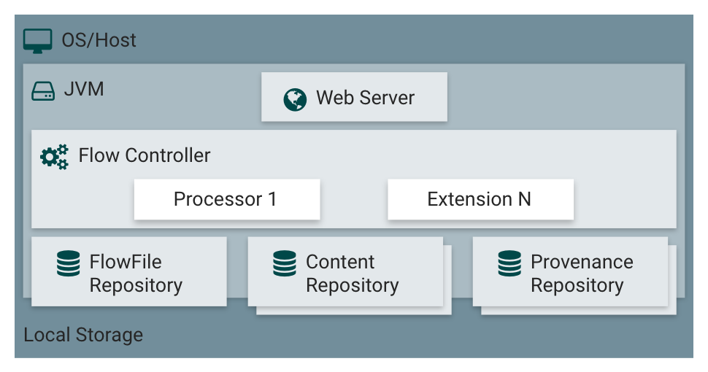

What are the components of Apache NiFi?
NiFi executes within a JVM on a host operating system. The primary components of NiFi on the JVM are as follows:

Web Server
The purpose of the web server is to host NiFi’s HTTP-based command and control API the drag-and-drop interface of the UI canvas.

Flow Controller
The flow controller is the brains of the operation. It provides threads for extensions to run on and manages the schedule of when extensions receive resources to execute.

Extensions
There are various types of NiFi extensions which are described in other documents. The key point here is that extensions operate and execute within the JVM.

FlowFile Repository
The FlowFile Repository is where NiFi keeps track of the state of what it knows about a given FlowFile that is presently active in the flow. The implementation of the repository is pluggable. The default approach is a persistent Write-Ahead Log located on a specified disk partition.

Database Repository
The Database Repository is where NiFi keeps track of the state of what it knows about a given FlowFile that is presently active in the flow.

Content Repository
The Content Repository is where the actual content in bytes of a given FlowFile are. The implementation of the repository is pluggable. The default approach is a simple, which stores blocks of data in the file system. More than one file system storage location can be specified to get different physical partitions engaged to reduce contention on any single volume.

Provenance Repository
The Provenance Repository is where all provenance event data is stored. The repository construct is pluggable with the default implementation uses one, but you can set it up to use multiple physical disk volumes. Within each location event data is indexed and made searchable.

Cluster requirements for NiFi
NiFi can also operate within a cluster but you will need to have a coordinator node which runs Zookeeper. When processing large data sets you will need a highly scalable server machine (such as a database server). Since the processed data is a copy of the original data and is kept in the content repository as the changes that happen along the way.

NiFi Cluster architecture
Apache NiFi has a Zero-Master Clustering paradigm that is employed. Each node in a NiFi cluster performs the same tasks on the data, but each operates on a different set of data. Apache Zookeeper elects a single node as the Cluster Coordinator and fail over is handled automatically by Zookeeper.

All cluster nodes report heartbeat and status information to the Cluster Coordinator. The Cluster Coordinator is responsible for disconnecting and connecting nodes. Additionally, every cluster has one Primary Node, also elected by Zookeeper.

As a DataFlow manager, you can interact with the NiFi cluster through the user interface (UI) of any node. Any change you make is replicated to all nodes in the cluster, allowing for multiple entry points.

Chapter 3

What is Apache Airflow

Apache Airflow is a workflow automation and scheduling system that can be used to author and manage data pipelines. Airflow uses workflows made of directed acyclic graphs (DAGs) of tasks.

Note: Airflow is currently in incubator status. Software in the Apache Incubator has not yet been fully endorsed by the Apache Software Foundation.
A DAG is a construct of nodes and connectors (also called “edges”) where the connectors have direction, and you can start at any arbitrary node to travel through all connectors. Each connector is traversed once. Trees and network topologies are types of DAGs.

Airflow workflows have tasks whose output is another task’s input. Therefore, the ETL process is also a type of DAG. In each step, the output is used as the input of the next step and you cannot loop back to a previous step.
Defining workflows in code provides easier maintenance, testing and versioning.

How is Apache Airflow different?
Airflow is not a data streaming platform. Tasks represent data movement, they do not move data in themselves. Thus, it is not an interactive ETL tool.

Airflow is a Python script that defines an Airflow DAG object. This object can then be used in Python to code the ETL process. Airflow uses Jinja Templating, which provides built-in parameters and macros (Jinja is a templating language for Python, modeled after Django templates) for Python programming.

Apache Airflow is a generic data toolbox that supports custom plugins. These plugins can add features, interact effectively with different data storage platforms (i.e. Amazon Redshift, MySQL), and handle more complex interactions with data and metadata.

Integrated with Amazon Web Services (AWS) and Google Cloud Platform (GCP) which includes BigQuery, Airflow has built in connections with these services. There are AWS and GCP hooks and operators available for Airflow and additional integrations will become available as Airflow matures.

Airflow ETL process
What is ETL/ELT and how does Airflow implement it. ETL is a process to extract data from various raw events or sources, then transform them for analysis and loading into a data store, file system, and databases. The job of data engineers and scientists is to build ETL pipelines which run at different time on schedules to gain insight on topics ranging from what products sell at a particular time of the year or in what weather or season, etc. A reliable, efficient, and trustworthy workflow management system is crucial to make sure these pipelines run successfully and deliver the data on its set schedule.

Apache Airflow is a workflow orchestration management system which allows users to programmatically author, schedule, and monitor data pipelines. Lyft was one of the first Airflow adopter in production since the project was open-sourced. Today, Workflow Management Systems have become one of the most important parts of any infrastructure that serves various use cases: from powering executive dashboards to metrics aggregation, to derived data generation, to machine learning computation.

In the context of Apache Airflow here are a few key terminologies that make up a pipeline system they are:

- DAG (Directed Acyclic Graph): a workflow which glues all the tasks with inter-dependencies.
- Operator: a template for a specific type of work to be executed. For example, BashOperator represents how to execute a bash script while PythonOperator represents how to execute a python function, etc.
- Sensor: a type of special operator which will only execute if a certain condition is met.
- Task: a parameterized instance of an operator/sensor which represents a unit of actual work to be executed.
- Plugin: an extension to allow users to easily extend Airflow with various custom hooks, operators, sensors, macros, and web views.
- Pools: concurrency limit configuration for a set of Airflow tasks.
- For other Airflow terminologies, please check out Airflow documentation for more details.

What is Apache Airflow’s Architecture

Airflow is typically composed of the following components listed below:

- Configuration file: All the configuration points like “which port to run the web server on”, “which executor to use”, “config related to RabbitMQ/Redis”, workers, DAGS location, repository etc. are configured.
- Metadata database (MySQL or PostgreSQL): The database where all the metadata related to the DAGS, DAG runs, tasks, variables are stored.
- DAGs (Directed Acyclic Graphs): These are the Workflow definitions (logical units) that contains the task definitions along with the dependency’s info. These are the actual jobs that the user would like to execute.
- Scheduler: A component that is responsible for triggering the DAG objects and job instances for each DAG. The scheduler is also responsible for invoking the Executor (be it Local or Celery or Sequential)
- Broker (Redis or RabbitMQ): In case of a Celery executor, the broker is required to hold the messages and act as a communicator between the executor and the workers.
- Worker nodes: The actual workers that execute the tasks and return the result of the task.
- Web server: A web server that renders the UI for Airflow through which one can view the DAGs, its status, rerun, create variables, connections etc.

How is Airflow Used under Python
Airflow is a platform to programmatically authoring, scheduling and monitoring workflows.
You can use airflow to author workflows as directed acyclic graphs (DAGs) of tasks.

The airflow scheduler executes your tasks on an array of workers while following the specified dependencies. It has a rich set of command line utilities.
Complex manipulations of DAGs are easy. The rich user interface makes it easy to visualize pipelines running in production, monitor progress, and troubleshoot issues when needed.

When workflows are defined as code, they become more maintainable, version able, testable, and collaborative. Function’s as an abstraction service for executing tasks at scheduled intervals.

Airflow Single Node Cluster
In Single Node Airflow Cluster, all the components (worker, scheduler, webserver) are installed on the same node which is then known as “Master Node”. To Scale a Single Node Cluster, Airflow must be configured with the LocalExecutor mode. Worker pulls the task to run from the IPC (Inter process communication) queue, this scales very well until the amount of resources available at the Master Node are exhausted. To scale Airflow on multi-node, Celery Executor must be enabled.

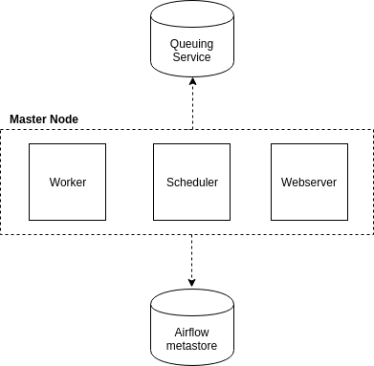

Airflow Single Node Architecture

Airflow Multi-Node Cluster
In Multi-node Airflow Architecture daemon processes are been distributed across all worker nodes. As Webserver and scheduler would be installed at Master Node and Workers would be installed at each different worker nodes so It can scale well horizontally as well as vertically. to use this mode of architecture, Airflow must be configured with CeleryExecutor.

Celery Backend needs to be configured to enable CeleryExecutor mode at Airflow Architecture. Popular framework / application for Celery backend are Redis and RabbitMQ. RabbitMQ is a message broker, its job is to manage communication between multiple task services by operating message queues. Instead of IPC communication channel which would be in Single Node Architecture, RabbitMQ Provides Publish / Subscribe mechanism model to exchange messages at different queues.

Each queue at RabbitMQ has published with events / messages as Task commands, Celery workers will retrieve the Task Commands from each queue and execute them as truly distributed and concurrent way. Which can really be accelerated the truly powerful concurrent and parallel Task Execution across the cluster.

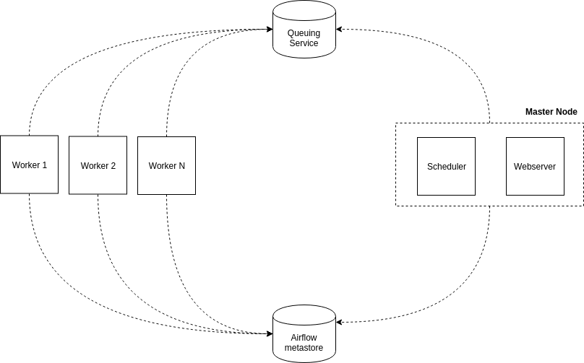

Airflow Multi-Node Architecture

Celery:
Celery is an asynchronous task queue/job queue based on distributed message passing. It is focused on real-time operation but supports scheduling as well. Airflow uses it to execute several Task level Concurrency on several worker nodes using multiprocessing and multitasking. Multi-node Airflow architecture allows you to Scale up Airflow by adding new workers easily.

Operators, Sensors, and Tasks
Although the DAG is used to organize tasks and set their execution context, DAGs do not perform any actual computation. Instead, tasks are the element of Airflow that actually “do the work” we want performed. Tasks can have two flavors: they can either execute some explicit operation, in which case they are an Operator, or they can pause the execution of dependent tasks until some criterion has been met, in which case they are a Sensor. In principle, Operators can perform any function that can be executed in Python. Similarly, Sensors can check the state of any process or data structure.

The code block below shows how we would define some (hypothetical) Operator and Sensor classes to implement our example workflow.

The code defines a subclass of BaseSensorOperator, the ConversionRatesSensor. This class implements a poke method, which is required for all BaseSensorOperator objects. The poke method must return True if the downstream tasks are to continue and False otherwise. In our example, this sensor would be used to determine when exchange rates from the external API have become available.

The two classes, ExtractAppStoreRevenueOperator and TransformAppStoreJSONDataOperator are inherited from Airflow’s BaseOperator class and implement an execute method. In our example, these two classes execute methods pull data from the app store APIs and transform them into the company’s preferred storage format. Notice that the ExtractAppStoreRevenueOperator also takes a custom parameter, app_store_name,which tells the class the app store from which to request data.

Note that generally Operators and Sensors are defined in separate files and imported into the same namespace we define the DAG. However, we could have added these class definitions to the same DAG-definition file as well.

Formally, Airflow defines a task as an instantiation of either the Sensor or Operator classes. Instantiating a task requires providing a unique task_id and DAG container in which to add the task (Note: in versions ≥ 1.8, there is no longer a DAG object requirement). The code block below shows how we would instantiate all the tasks needed to perform our example workflow. (Note: We assume that all Operators that are being referenced in our examples have been defined in or imported into our namespace).

This task instantiation code is executed in the same file/namespace as the DAG definition. We can see that the code for adding tasks is concise and allows for in-line documentation via comments. Lines 10–19 demonstrate one of the strengths of defining workflows in code. We can dynamically define three separate tasks for extracting data from each of the app stores using a for loop. Though this approach may not buy us much in this small example, the benefits are huge as the number of app stores increases.

Defining Task Dependencies
A key strength of Airflow is the concise and intuitive conventions for defining dependencies among tasks. The code below shows how we would define the task dependency graph for our example workflow:

Again, this code is run in the same file/namespace as the DAG definition. Task dependencies are set using the set_upstream and set_downstream operators (Though, in version ≥ 1.8, it’s also possible to use the bitshift operators << and >> to perform the same operations more concisely). A task can have multiple dependencies (e.g. combine_revenue_data), or none at all (e.g. all extract_* tasks).

The Top Subpanel of Figure 3.2 shows the Airflow DAG created by the above code, as rendered by Airflow’s UI (we’ll soon get to the UI in more detail). The DAG has a dependency structure that is very similar the execution plan we came up with for our example workflow shown in Figure 1.1. When the DAG is being executed, Airflow will also use this dependency structure to automagically figure out which tasks can be run simultaneously at any point in time (e.g. all the extract_* tasks).

DagRuns and TaskInstances
Once we’ve defined a DAG — i.e. we’ve instantiated tasks and defined their dependencies — we can then execute the tasks based on the parameters of the DAG. A key concept in Airflow is that of an execution_time. When the Airflow scheduler is running, it will define a regularly-spaced schedule of dates for which to execute a DAG’s associated tasks. The execution times begin at the DAG’s start_date and repeat every schedule_interval. For our example the scheduled execution times would be (‘2017–01–01 00:00:00’, ‘2017–01–02 00:00:00’, ...). For each execution_time, a DagRun is created and operates under the context of that execution time. Thus a DagRun is simply a DAG with some execution time (see the Bottom Subpanel of Figure 3.2).

All the tasks associated with a DagRun are referred to as TaskInstances. In other words a TaskInstance is a task that has been instantiated and has an execution_date context (see Bottom Subpanel of Figure 3.2). DagRuns and TaskInstances are central concepts in Airflow. Each DagRun and TaskInstance is associated with an entry in Airflow’s metadata database that logs their state (e.g. “queued”, “running”, “failed”, “skipped”, “up for retry”). Reading and updating these states is key for Airflow’s scheduling and execution processes.

Airflow’s Architecture
At its core, Airflow is simply a queuing system built on top of a metadata database. The database stores the state of queued tasks and a scheduler uses these states to prioritize how other tasks are added to the queue. This functionality is orchestrated by four primary components (refer to the Left Subpanel of Figure 3.2):

- Metadata Database: this database stores information regarding the state of tasks. Database updates are performed using an abstraction layer implemented in SQLAlchemy. This abstraction layer cleanly separates the function of the remaining components of Airflow from the database.
- Scheduler: The Scheduler is a process that uses DAG definitions in conjunction with the state of tasks in the metadata database to decide which tasks need to be executed, as well as their execution priority. The Scheduler is generally run as a service.
- Executor: The Executor is a message queuing process that is tightly bound to the Scheduler and determines the worker processes that actually execute each scheduled task. There are different types of Executors, each of which uses a specific class of worker processes to execute tasks. For example, the LocalExecutor executes tasks with parallel processes that run on the same machine as the Scheduler process. Other Executors, like the CeleryExecutor execute tasks using worker processes that exist on a separate cluster of worker machines.
- Workers: These are the processes that actually execute the logic of tasks, and are determined by the Executor being used.

Airflow’s operations are built atop a Metadata Database which stores the state of tasks and workflows (i.e. DAGs). The Scheduler and Executor send tasks to a queue for Worker processes to perform them. The Webserver runs (often-times running on the same machine as the Scheduler) and communicates with the database to render task state information and Task Execution Logs in the Web UI.

Scheduler Operation
At first, the operation of Airflow’s scheduler can seem more like black magic than a logical computer program. That said, understanding the workings of the scheduler can save you a ton of time if you ever find yourself debugging its execution. To save the reader from having to dig through Airflow’s source code (though we DO highly recommend it!), we outline the basic operation of the scheduler in pseudo-code:

Web UI
In addition to the primary scheduling and execution components, Airflow also includes components that support a full-featured Web UI (refer to Figure 3.2 for some UI examples), including:

Webserver: This process runs a simple Flask application which reads the state of all tasks from the metadata database and renders these states for the Web UI.
Web UI: This component allows a client-side user to view and edit the state of tasks in the metadata database. Because of the coupling between the Scheduler and the database, the Web UI allows users to manipulate the behavior of the scheduler.
Execution Logs: These logs are written by the worker processes and stored either on disk or a remote file store (e.g. GCS or S3). The Webserver accesses the logs and makes them available to the Web UI.

Though these additional components are not necessary to the basic operation of Airflow, they offer functionally that really sets Airflow apart from other current workflow managers. Specifically the UI and integrated execution logs allows users to inspect and diagnose task execution, as well as view and manipulate task state.

Airflow Multi-Node Cluster with Celery Installation and Configuration steps:

Note: We are using CentOS 7 Linux operating system.

1. Install RabbitMQ
- yum install epel-release
- yum install rabbitmq-server
2. Enable and start RabbitMQ Server
- systemctl enable rabbitmq-server.service
- systemctl start rabbitmq-server.service
3. Enable RabbitMQ Web Management Console Interface
- rabbitmq-plugins enable rabbitmq_management

The Airflow UI makes it easy to monitor and troubleshoot your data pipelines. Here’s a quick overview of some of the features and visualizations you can find in the Airflow UI.

DAGs View¶
List of the DAGs in your environment, and a set of shortcuts to useful pages. You can see exactly how many tasks succeeded, failed, or are currently running at a glance.

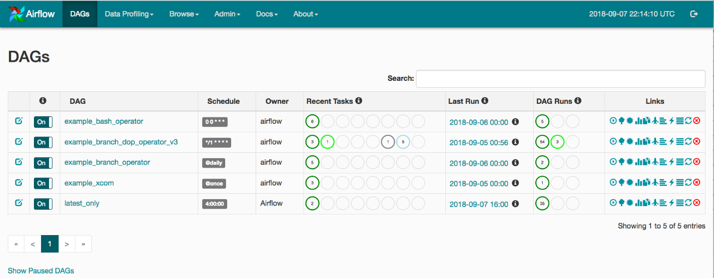

Tree View¶
A tree representation of the DAG that spans across time. If a pipeline is late, you can quickly see where the different steps are and identify the blocking ones.

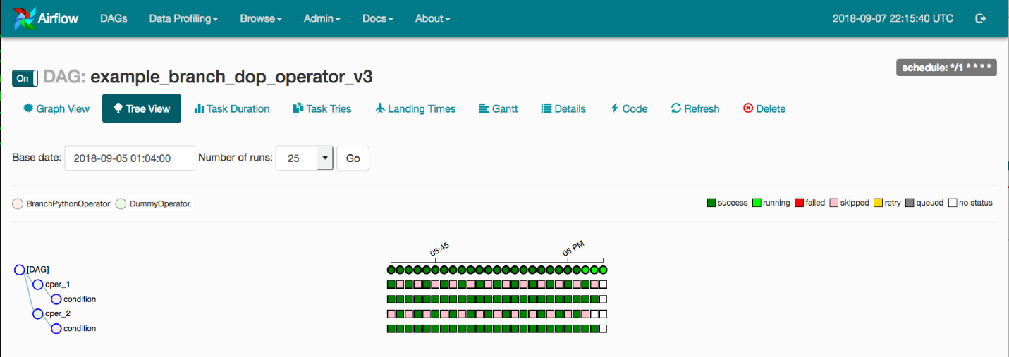

Graph View¶
The graph view is perhaps the most comprehensive. Visualize your DAG’s dependencies and their current status for a specific run.

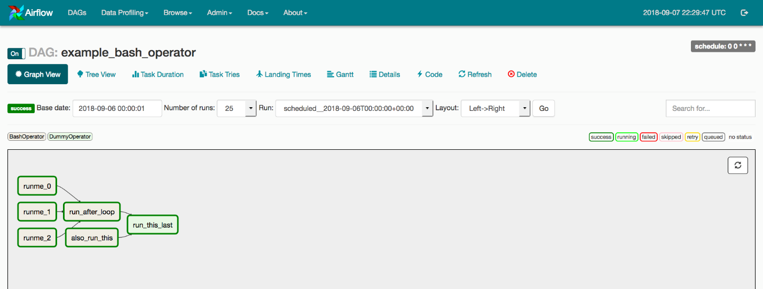

Variable View¶
The variable view allows you to list, create, edit or delete the key-value pair of a variable used during jobs. Value of a variable will be hidden if the key contains any words in (‘password’, ‘secret’, ‘passwd’, ‘authorization’, ‘api_key’, ‘apikey’, ‘access_token’) by default, but can be configured to show in clear-text.

Graph View¶
The graph view is perhaps the most comprehensive. Visualize your DAG’s dependencies and their current status for a specific run.

Variable View¶
The variable view allows you to list, create, edit or delete the key-value pair of a variable used during jobs. Value of a variable will be hidden if the key contains any words in (‘password’, ‘secret’, ‘passwd’, ‘authorization’, ‘api_key’, ‘apikey’, ‘access_token’) by default, but can be configured to show in clear-text.

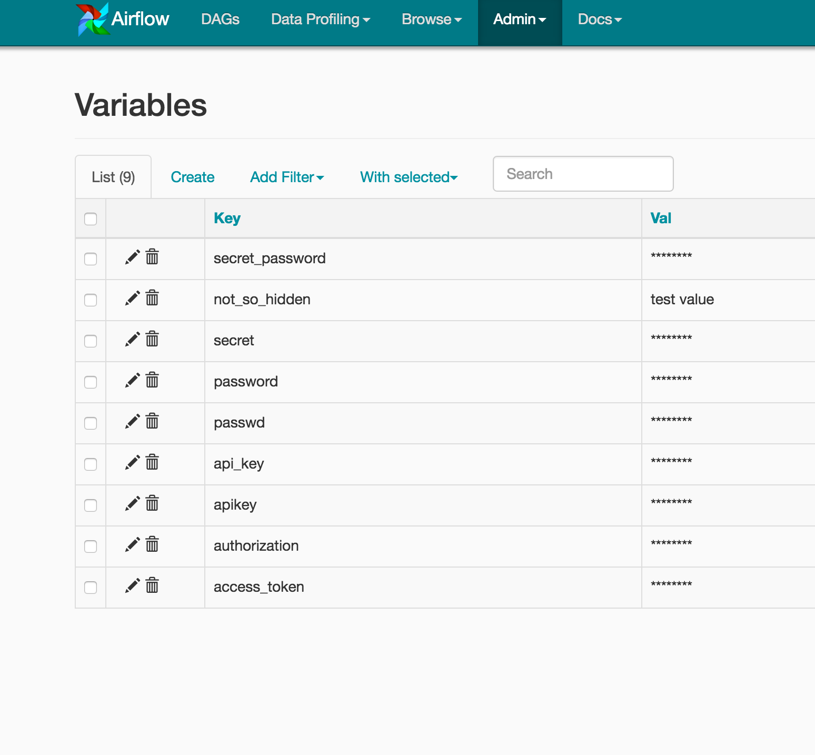

Gantt Chart¶
The Gantt chart lets you analyze task duration and overlap. You can quickly identify bottlenecks and where the bulk of the time is spent for specific DAG runs.

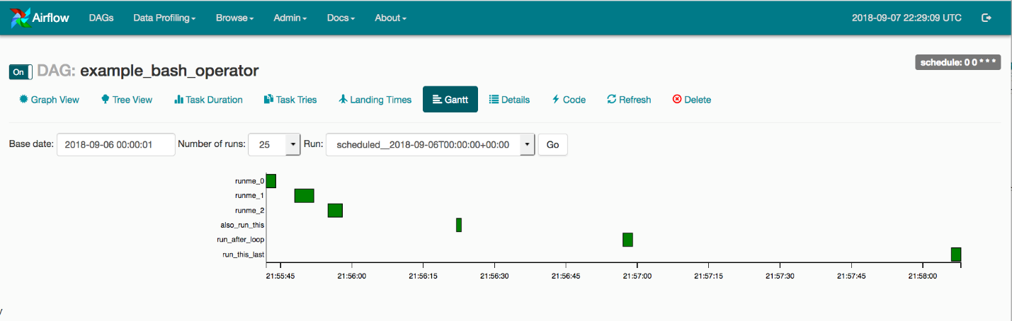

Task Duration¶
The duration of your different tasks over the past N runs. This view lets you find outliers quickly understand where the time is spent in your DAG over many runs.

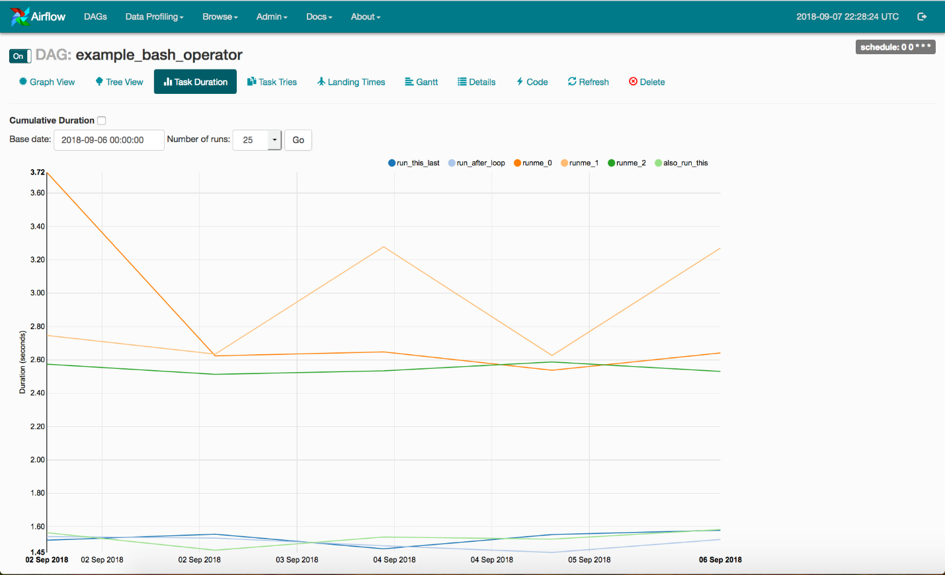

Code View
Transparency is everything. While the code for your pipeline is in source control, this is a quick way to get to the code that generates the DAG and provide yet more context.

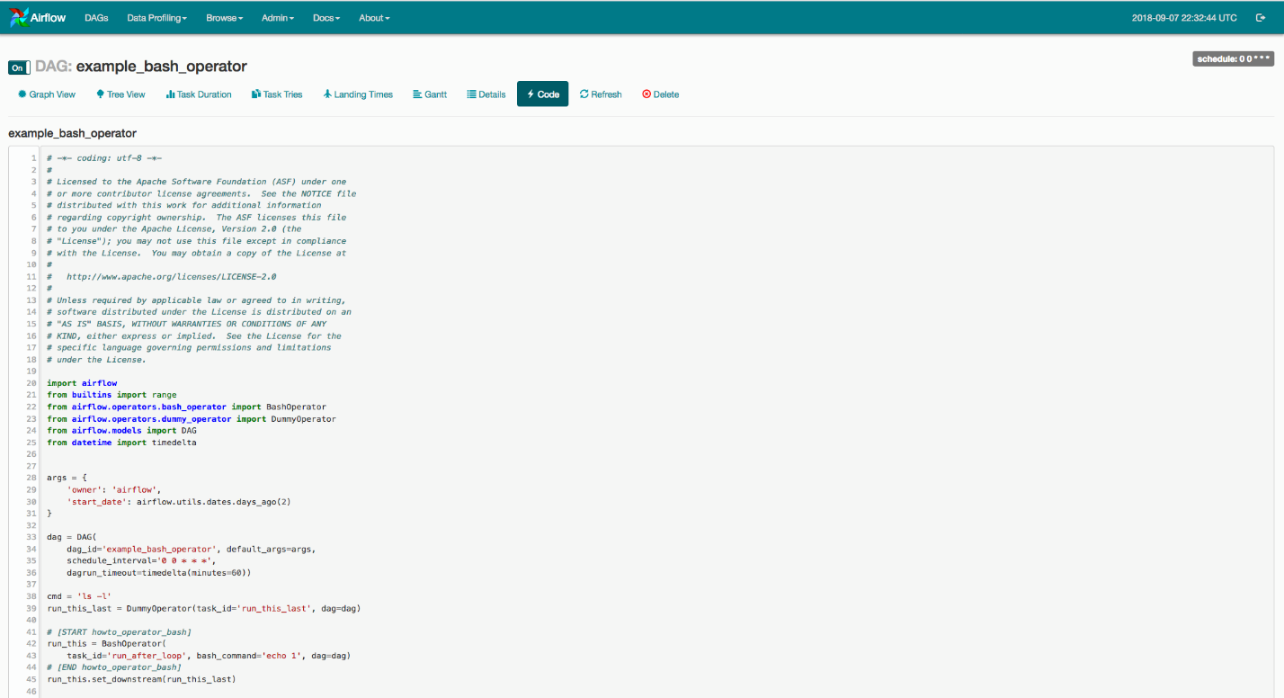

Task Instance Context Menu¶
From the pages seen above (tree view, graph view, Gantt, …), it is always possible to click on a task instance, and get to this rich context menu that can take you to more detailed metadata, and perform some actions.

Chapter 4
What is Spotify Luigi

The easiest way to understand Luigi is that it’s a python package that is used to build complex pipelines and it was developed at Spotify. In Luigi, as in Airflow, you can specify workflows as tasks and dependencies between them.

The two building blocks of Luigi are Tasks and Targets. A target is a file usually outputted by a task, a task performs computations and consumes targets generated by other tasks.

Luigi has 2 types of components: workers and the central scheduler. You can see the workers as your batch jobs executors (the applications themselves) whilst the central scheduler is just a guy that tells the workers if a job is OK to execute, if it’s already done, being executed or whatever.

You can simply run luigi central scheduler in a container, using something like this. The only thing needed for it to run properly is to configure your luigi.cfg. After you have it up and running, Luige’s central scheduler web interface will look like this:

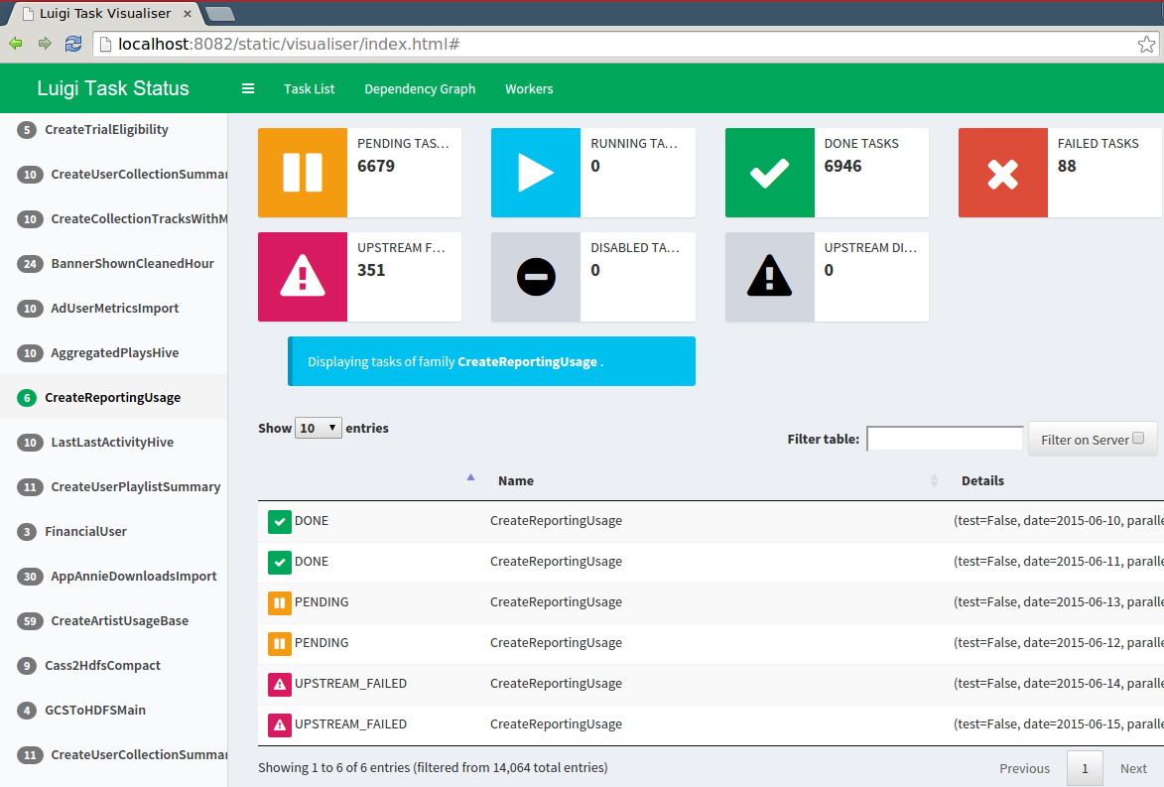

Luigi is mainly based on two object types: Tasks and Targets. The idea behind Luigi is that usually, a process produces an output, which is stored in a file or database before being picked up by another process to perform transformations or aggregations or both.

If the output produced by the first process does not exist, then the second process cannot be run. For Luigi, a process is called a Task and the output is a Target. The premise is simple, a Task produces a Target, and the existence of this Target will be used by dependent Tasks to assess whether they can be run.

This allows users to easily build entire schedules of Tasks that depend on each other. Luigi will first verify if the topmost Task’s Target exists. If not, Luigi will verify whether the dependencies are complete (whether their Targets exist) and run them if they don’t. If these dependencies have dependencies themselves, Luigi will verify them as well, and so on until it finds Tasks that are complete or that do not require dependencies. It will then run the whole tree of dependencies to finish by the topmost Task.

Tasks
Tasks offer three different methods to override:

1. The requires() function to specify the required dependencies, usually one Task or a list of Tasks
2. The output() function to specify the Target created by the Task
3. The run() function is used to specify which of the operation the Task will perform and how it will create the Target from the output() method

In addition, there are special kinds of Tasks that do not require all three methods to be set. For example, ExternalTask does not require a run() method and represent an external resource, i.e. a Scala Spark job. WrapperTask has no run() nor method and is used to aggregate multiple Tasks that must be run together.

Targets
Targets offer one method: exist() method, which should be overridden and should return True if the Target exists. Luigi already provides a few of them, i.e. LocalTarget, which represents a file on the system. Many more can be found in the different contribution packages, depending on your preferred technology stack.

Parameters
In addition, Luigi provides a way to pass on parameters to the Tasks to be run, under the form of Parameter objects. These can represent any type of object that can be passed on to a Task, and that will be used to perform the Task and verify dependencies. Parameter objects are defined at class level, but their value is assigned at instance level. Luigi will regard two Task instances with different Parameter values as different. The different Task instances will be run separately, unless one of these Parameters is set to be insignificant.

How do you set up a luigi pipeline?
Now that we have presented the main principles, we will introduce a way to put a pipeline in place that will output an arbitrary number of reports based on SQL query files.

Goal
Let’s say you have a series of databases and that you need to produce Excel reports based on SQL queries ran against these databases. You want to automatize that process, so that whenever you put a new SQL file in a dedicated folder (one per database), a report will be produced and dropped in an output folder, with the same name as the query file.

For the sake of this exercise, we will use a csv file generated by means of the USGS earthquakes API, on a period between 15 September 2018 and 1 October 2018, worldwide, with all magnitudes. You can access the data on Github or download it here.

The generated csv will be in a folder called ‘data’ in the same directory as the code. It will then be picked up by a Luigi Task and sent to an SQLite database located in that directory. This will be done via a pandas Data Frame, to focus on the luigi code. We will use SQLAlchemy to manage the connections to the databases because this offers the right level of abstraction here.

Overview
The idea is to have two directories: ‘queries’ and ‘results. The ‘queries’ directory is subdivided into different directories, each one hosting queries related to a different database. Each valid query added in one of the subdirectories will be run and will produce a report, such as an Excel file.

Looking into Luigi: A Workflow Management System Review
Data intelligence relies on a strong, functional data pipeline. However, the workflows that feed those pipelines can be rather arbitrarily complex.

Building, connecting, and maintaining complex workflows add unnecessary work for data engineers.\

It’s not an arrangement that works in the fast-paced world of enterprise software.
Fortunately, developers can lower their workload with tools like Luigi.

What Is Luigi
Spotify created and maintains Luigi, a workflow engine whose philosophy and concepts were inspired by GNU Make.
It’s a Python module that provides a framework for building and running complex pipelines of batch jobs.

What problem does Luigi solve?
Luigi’s main function is to take care of workflow management so developers can focus on other concerns.

It can be used to help build data pipeline tasks like declaring dependencies between tasks or defining the inputs and outputs of each task.

On top of creating data pipeline tasks, Luigi helps run them. It’s a good tool for handling dependencies, providing visualization tools, and handling and reporting failures.
When used with a central scheduler it can also enable distributed execution.

Benefits of Luigi
Smoothly resume data workflow after a failure.
Parametrize and re-run tasks on a schedule (daily, hourly, or as needed) with the help of an external trigger.

Organize code with shared patterns.
Command line integration.
Small overhead for a task (about 4 lines: class, def requires, def output, def run).
Everything is done by inheriting Python classes.
Can be extended with other tasks such as Spark jobs, Hive queries, and more.

Strengths of Luigi
Modular code makes software more reliable and easier to main and update.
With Luigi, writing modular code is simple. Developers can easily create complicated dependencies between tasks.

Better yet, managing those dependencies is equally straightforward.
Luigi’s simple API lets users build a build a highly complex tree of dependencies without making it too difficult to understand.

Other team members or outside maintainers can easily interpret the code.
Luigi is highly flexible. It relies on Python, which allows developers the freedom to create tasks that do anything needed.

Connecting components is easy and intuitive.
There’s no external or static configuration for the pipelines, only Python scripts, so everything is dynamic.

Last – but not least – is idempotency. Completed tasks are not run twice, so a failed workflow can be restarted from the middle.

It picks up right where it left off, which produces the same output every time.

Weaknesses of Luigi
One of Luigi’s main weaknesses is the flip-sides of one of its biggest strengths.
Specifically, it can’t re-run partial or old pipelines since it picks up where it left off.
It also has no native support for distributed execution.

Developers need to use a central controller to gain that functionality.
Some have found Luigi’s user interface to be hard to navigate.
This is one of the biggest reason’s users move to Airflow, though with some practice the UI issue becomes less noticeable.

The biggest complaints of developers who’ve worked with Luigi revolve around issues with scaling.
There are two reasons for the tool’s scalability issues:
The number of Luigi worker processes is limited by the number of cron worker processes currently assigned to the job.

The web UI and scheduler run on a single threaded process. If the scheduler is busy or someone else is using the UI, the web UI suffers from frustratingly slow performance.
Comparison

Airflow (Airbnb)
Airbnb uses a lot of data heavy features: price optimization for hosts, property recommendations for guests, and internal tracing features to guide business decisions.
They created Airflow to meet their specific data needs, then decided to open source it in 2015.
It’s flexible and scalable, but users have experienced some problems with time zones, managing the scheduler, and unexpected backfills.
Pinball (Pinterest)
Pinterest created Pinball when they found none of the existing workflow management solutions met their requirements for customizability.
It has a lot of features and scales horizontally very well.
The community is small, though, and it doesn’t have good documentation.

Real-life Application
In practice Luigi is used for ETL (extract, transform, load) operations that feed data intelligence operations.
Luigi handles batch jobs, not streaming, continuous processes.
It’s not a data integration software, but it can be used to orchestrate custom data integration tasks.

The Task class is a bit more conceptually interesting because this is where computation is done. There are a few methods that can be implemented to alter its behavior, most notably run(), output() and requires().
Tasks consume Targets that were created by some other task. They usually also output targets:

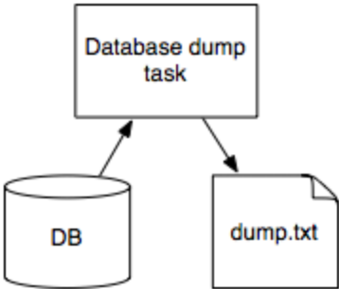

You can define dependencies between Tasks using the requires() method. See Tasks for more info.

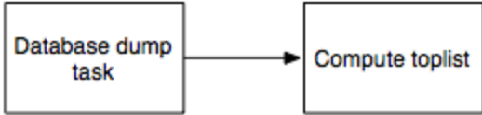

Each task defines its outputs using the output() method. Additionally, there is a helper method input() that returns the corresponding Target classes for each Task dependency.

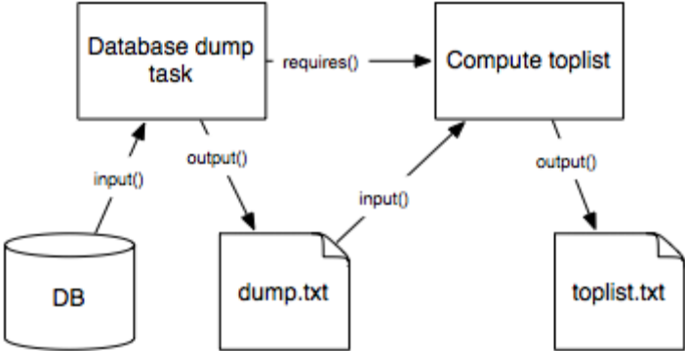

These diagrams are from a Luigi presentation in late 2014 at NYC Data Science meetup

What is Spotify Luigi’s Architecture

A lot of the time solving a business problem or improving a system depends on acquiring data and playing with it. After acquiring data, transforming it into something useful, gathering insights and proposing solutions, features or improvements we usually want to turn this into an automatic process.

What I mean by an automatic process is usually a sequence of tasks (batch jobs). Something like “get some data”, “transform data” and “use data”. This also has a fancier name: pipeline (of batch jobs).

I’ll try to better illustrate the issue. For example, a pipeline that consists into 3 separate batch jobs and each job has its own dependencies:

Mock pipeline
The arrows represent dependency, that means that “transform data” must only be executed after “get some data” is complete. There is a fancy name for this kind of structure: Directed Acyclic Graph (or DAG), which in short, is just a “one way” graph.

During the development of those pipelines some issues arise. These issues include dependency resolution, workflow management, visualization, handling failures, task triggering and monitoring (basically what the documentation says Luigi does).

That are different possible ways to address the possible adversities intrinsic to pipelines. The main ones explored by us were a couple of python packages, Airflow from Airbnb and Luigi from Spotify. As you probably guessed, we chose Luigi. The reasons being:

Source: https://www.mariowiki.com/Luigi
Better integration with our services architecture
Faster to develop
Less complex
Luigi is cool

Luigi has 2 types of components: workers and the central scheduler. You can see the workers as your batch jobs executors (the applications themselves) whilst the central scheduler is just a guy that tells the workers if a job is OK to execute, if it’s already done, being executed or whatever.
How Luigi exactly works is outside the scope of this post, what I intend to focus here is how we are using it. If you want to dive deep into the package you can always read the docs.

You can simply run luigi central scheduler in a container, using something like this. The only thing needed for it to run properly is to configure your luigi.cfg. After you have it up and running, luigi’s central scheduler web interface will look like this:

Source: luigi docs
To use the package on your workers is also very simple. First, you will need your luigi.cfg file, you can use the same one from the central scheduler. Second, if you have an existing application that runs your jobs without monitoring and etc. (like I did) is basically creating a file (tasks_luigi or luigi_tasks if you are as creative as me) containing the service’s tasks description and then simply run it.

The following block is a mock luigi task based on the mock pipeline at the beginning of the text:

class TransformDataTask(luigi.Task):
date = luigi.DateParameter(default=datetime.date.today())
def requires(self):
return GetDataTask(self.date)
def output(self):
return luigi.Target()
def run(self):
transform_data()

These pipelines are usually executed periodically and luigi does not come with a triggering mechanism for your tasks. However, you can trigger it using a crontab for example. Based on the task above the command to run it would be the following:
python -m luigi --module luigi_tasks TransformDataTask --date 2017-05-04

The way execution works is very simple. Just tell luigi to run the last task on your pipeline and that task will require its dependencies. Then, these dependencies will require their own dependencies and it will go on until None is required. Pretty simple right? Luigi has a top-down approach to build the execution graph based on tasks’ requirements and then executes it from beginning to end (or failure).
Now, finally to a real example. The following illustration is a simplified scheme of the workflow of 2 Apps that use luigi to handle their batch jobs’ pipelines.

Example of a simplified fluxogram
To explain a little of the 2 apps on the workflow above, the Facebook Ads App acquires Marketing data, merges it with our own data and performs some Ads management activities. The Machine Learning App (MLApp) gathers data, transforms it, trains a machine learning model and leaves it into S3 so our Predictive App can fetch it and use it to make useful predictions, cool huh?!
In the MLApp the pipeline executed is very similar to the two last steps in the mock pipeline. What’s done is to preprocess (transform) some data and then train (use) a model on this data. After the former is done, the model is evaluated and this data is sent somewhere.

MLApp pipeline visualization
On the left, we have the pipeline (or DAG) visualization provided by luigi. You can access it in your central scheduler very easily. For example, if this pipeline fails at EvaluateAll, you can simply fix the problem at hand and just execute this last step again (if you use luigi correctly, of course).

Color legend
On this last graph, each color represents the batch job state.
I put the color legend for the graphs for the more curious ones.
Although the MLApp pipeline is very simple, luigi is still quite useful since in case something goes wrong we can know which step it was and keep executing from it. This is all possible because luigi checks if a task has its dependencies completed every time a task is scheduled to be executed. Also, luigi can retry tasks automatically and send error messages if anything happens. This is useful for a few reasons I will cover later.

The Facebook Ads App has a little more complex (and beautiful) pipeline. Each job was done successfully in this example, but it’s here just to show that luigi can handle more complex stuff (although this is not too complex to be honest).

Luigi DAG viz example
To tackle the question of why you should use luigi for monitoring your pipeline I will tell you the problem I had. My workers (batch job executors) were instances that had a schedule to turn on at some predefined time and to turn off when is done with its tasks. However, the EC2 instances also had a scheduled action to commit suicide (turn off) after a long time running or if it fails (sad I know). So how would I know the pipeline failed? Even worse, the machine used to die with my logs on it (damn it!). I also found an answer in luigi for this problem.
Now, about the time I told luigi could send you error messages, I lied. (but don’t panic yet)

Luigi solves all the problems mentioned before but monitoring and alarming errors. So, to complete the solution I found an interesting package: luigi-slack. What it does is very simple, sends Slack messages about any unexpected (or expected as well) events during the pipeline execution.

